**Assignment: Servlets**

**Create a Java web application using servlets which take 2 numbers and the operation to be performed on them as input from users and display the result on the next page. The operations which can be performed are**

1. **Addition**
2. **Subtraction**
3. **Multiplication**
4. **Division**

Procedure:

1. Create a new maven project with **maven-archetype-webapp**
2. Add the following dependency to the **pom.xml**

 <dependency>

      <groupId>jakarta.servlet</groupId>

      <artifactId>jakarta.servlet-api</artifactId>

      <version>6.0.0</version>

      <scope>provided</scope>

    </dependency>

1. The project structure will be as follows:

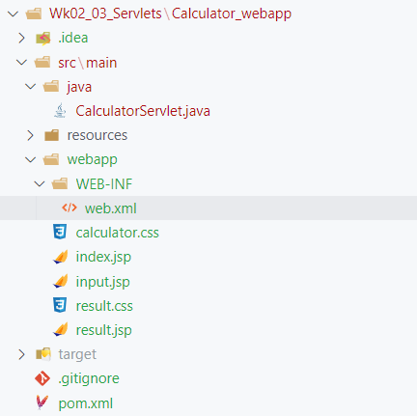

1. To the **CalculatorServlet.java**, add the following code-

package *W*k02_03_*S*ervlets.*C*alculator_webapp.src.main.java;

import jakarta.servlet.ServletException;

import jakarta.servlet.annotation.WebServlet;

import jakarta.servlet.http.HttpServlet;

import jakarta.servlet.http.HttpServletRequest;

import jakarta.servlet.http.HttpServletResponse;

import java.io.IOException;

@WebServlet("/calculate")

public class CalculatorServlet extends HttpServlet {

    protected void doPost(HttpServletRequest request, HttpServletResponse response)

            throws ServletException, IOException {

        int number1 = Integer.parseInt(request.getParameter("num1"));

        int number2 = Integer.parseInt(request.getParameter("num2"));

        String operation = request.getParameter("Operator");

        int result = 0;

        switch (operation) {

            case "+":

                result = number1 + number2;

                break;

            case "-":

                result = number1 - number2;

                break;

            case "*":

                result = number1 * number2;

                break;

            case "/":

                if (number2 != 0) {

                    result = number1 / number2;

                } else {

                    request.setAttribute("result", "Number cannot be divided by zero");

                    request.getRequestDispatcher("result.jsp").forward(request, response);

                    return;

                }

                break;

            default:

                request.setAttribute("result", "The operation is not valid!");

                request.getRequestDispatcher("result.jsp").forward(request, response);

                return;

        }

        request.setAttribute("result", result);

        request.getRequestDispatcher("result.jsp").forward(request, response);

    }

}

1. Add the following jsp files-

**input.jsp**

<!DOCTYPE html>

<html>

<head>

    <title>Calculator</title>

    <link rel="stylesheet" type="text/css" href="calculator.css">

</head>

<body>

    <div class="container">

        <h2>Calculator</h2>

        <form action="calculate" method="post">

            Enter First Number: <input type="number" name="num1" required><br>

            Enter Second Number: <input type="number" name="num2" required><br>

            Select Operation:

            <select name="Operator" required>

                <option value="+">Add</option>

                <option value="-">Subtract</option>

                <option value="*">Multiply</option>

                <option value="/">Divide</option>

            </select><br>

            <input type="submit" value="Calculate">

        </form>

    </div>

</body>

</html>

**result.jsp**

<!DOCTYPE html>

<html>

<head>

    <title>Result</title>

    <link rel="stylesheet" type="text/css" href="result.css">

</head>

<body>

    <div class="container">

        <h2>Result</h2>

        <p class="result">The result is: *<*%= request.getAttribute("result") %></p>

    </div>

</body>

</html>

1. Add css for styling-

**result.css**

body {

    font-family: Arial, sans-serif;

    background-color: #f4f4f4;

    margin: 0;

    padding: 0;

}

.container {

    width: 80%;

    margin: 0 auto;

    text-align: center;

}

h2 {

    color: #333;

}

.result {

    font-size: 24px;

    color: #008000;

}

**calculator.css**

body {

    font-family: Arial, sans-serif;

    background-color: #f4f4f4;

    margin: 0;

    padding: 0;

}

.container {

    width: 50%;

    margin: 0 auto;

    text-align: center;

}

h2 {

    color: #333;

}

form {

    margin-top: 20px;

    padding: 20px;

    background-color: #fff;

    border-radius: 5px;

    box-shadow: 0 0 10px rgba(0, 0, 0, 0.1);

}

input[type="number"],

select {

    padding: 10px;

    width: 100%;

    margin-bottom: 10px;

    border: 1px solid #ccc;

    border-radius: 5px;

}

input[type="submit"] {

    background-color: #4CAF50;

    color: white;

    padding: 14px 20px;

    margin: 8px 0;

    border: none;

    border-radius: 5px;

    cursor: pointer;

}

input[type="submit"]:hover {

    background-color: #45a049;

}

1. Add the following to web.xml-

<?xml version="1.0" encoding="UTF-8"?>

<web-app xmlns="http://xmlns.jcp.org/xml/ns/javaee"

         xmlns:xsi="http://www.w3.org/2001/XMLSchema-instance"

         xsi:schemaLocation="http://xmlns.jcp.org/xml/ns/javaee

         http://xmlns.jcp.org/xml/ns/javaee/web-app_4_0.xsd"

         version="4.0">

  <servlet>

    <servlet-name>CalculatorServlet</servlet-name>

    <servlet-class>CalculatorServlet</servlet-class>

  </servlet>

  <servlet-mapping>

    <servlet-name>CalculatorServlet</servlet-name>

    <url-pattern>/calculate</url-pattern>

  </servlet-mapping>

  <welcome-file-list>

    <welcome-file>input.jsp</welcome-file>

  </welcome-file-list>

</web-app>

1. Run the project using the Tomcat Server-

<http://localhost:8080/Calculator_webapp/>

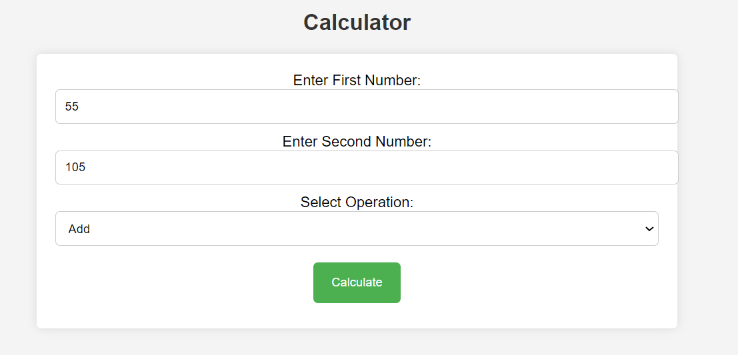

<http://localhost:8080/Calculator_webapp/calculate>



